Michael Chizy, Chairman  John L. Hebert, Vice Chairman  Richard Hersom, Clerk  Ryan Fattman  Kevin Geraghty  James A. Smith, Town Administrator | 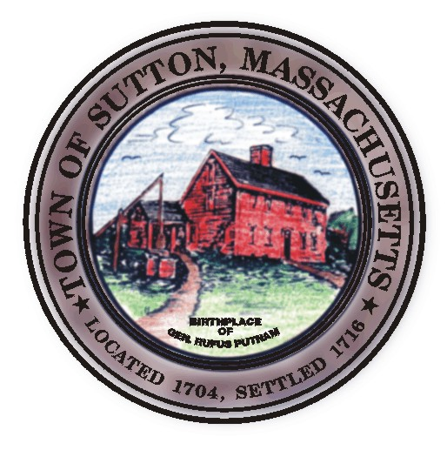 | Sutton Town Hall  4 Uxbridge Road  Sutton, Massachusetts 01590  (508) 865-8727  Fax: (508) 865-8721
Town Of Sutton
Board Of Selectmen

Meeting Agenda

7:00 p.m. – Tuesday, August 19, 2008

Sutton Town Hall, Selectmen’s Meeting Room

- Call to Order, Pledge of Allegiance at 7:00 p.m.

- Public Forum: Limited to 5 minutes per topic. Discussion or comments about town employees or agency members shall be avoided so as not to violate individual’s rights.

- Minutes
  - Board of Selectman minutes from 08/05/2008
Executive Session minutes 08/05/08

IV. Sponsored Agenda and Action Items

2. Appointment to Recreation Commission – Brian Allen
3. Approval of State Primary Election Warrant
4. Acceptance of Shaw Farm Confirmatory Deed
5. Warrant Article approval for Quarterly Billing to be placed on Fall Town Meeting

V. Town Administrator Update
VI. Announcements
VII. Selectman’s Roundtable: Correspondence and Business Topics
VIII. Executive Session

Adjournment

